**Project Name: Product Details Portal**

**Developer Name:** Kapil Davey

**GitHub Link:- https://github.com/kapildavey/Phase-2.git**

**Enter product details portal:**

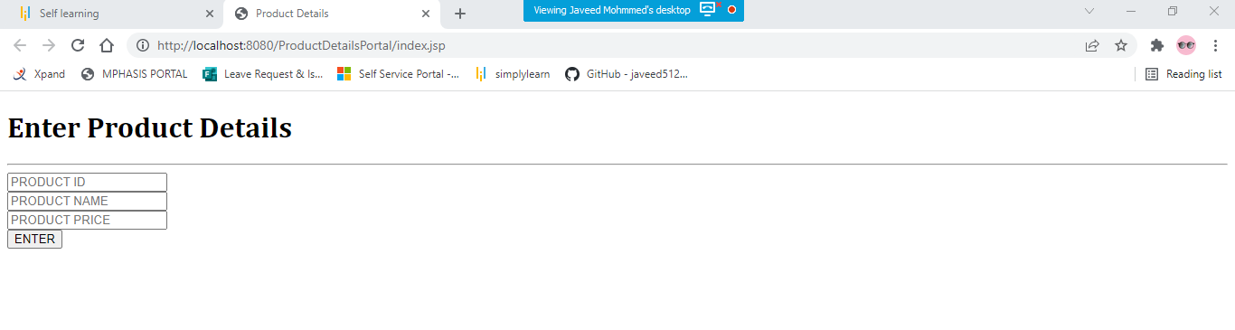

**Product Details Portal Output:**

